

Friday, November 28, 2025
McKenzie Elementary School wishes to recognize and acknowledge the Esquimalt and Songhees Nations, on whose traditional territories, we live, we learn, we play, and we do our work.

Administrators’ Message:

Today was the last day of Term 1! There has been so much learning this term and lots of progress to celebrate. Teaching staff are focusing on preparing detailed learning updates for families and we look forward to reading about all of this term’s successes in the coming weeks.

It was uplifting to see the sunshine today. Let’s hope we get a few more days of it. Enjoy your weekend.

Carmen & Jordana

Mark your calendar: 10 Days of Giving at McKenzie Dec 1st - 12th
Monday | Tuesday | Wednesday | Thursday | Friday
Dec. 1  Div 1 & 5 Skating  Start of Term 2 | Dec. 2 | Dec. 3  Div 7 & 9 Skating  Div 2 Goldstream | Dec. 4 | Dec. 5  Div 2 & 12  Gingerbread House Fieldtrip
December 2025
GVSD#61 Diversity, Equity & Inclusion Calendar

3rd – International Day of Persons with Disabilities
6th – National Day of Remembrance and Action of Violence Against Women
10th – Human Rights Day
15th – Hanukkah
21st – December Solstice
25th – Christmas
26th – Boxing Day
26th – Kwanzaa
UPCOMING DATES TO NOTE:
Dec. 1st – 12th – 10 Days of Giving
Dec. 1st – Div 1 & 5 Skating
Dec. 3rd – Div 2 Goldstream Hatchery and Div 7 & 9 Skating
Dec. 5th – Div 2 & 12 City bus to see Gingerbread Houses
Dec. 9th – Div 11 & 12 visit the Victorian
Dec. 10th – PAC meeting
Dec. 11th THEME DAY – Holiday Hats
Dec. 12th – PAC Hot Lunch & Learning Updates Live
Dec. 16th – THEME DAY - Holiday Clothing Explosion

2025-26 SCHOOL GROWTH PLAN FOR MCKENZIE SCHOOL:

SOCIAL EMOTIONAL LEARNING GOAL: As a staff and community, we will provide students with opportunities to improve or increase their sense of belonging at school.

LITERACY GOAL: To improve writing through more explicit, tactile, and oral language pre- writing strategies.

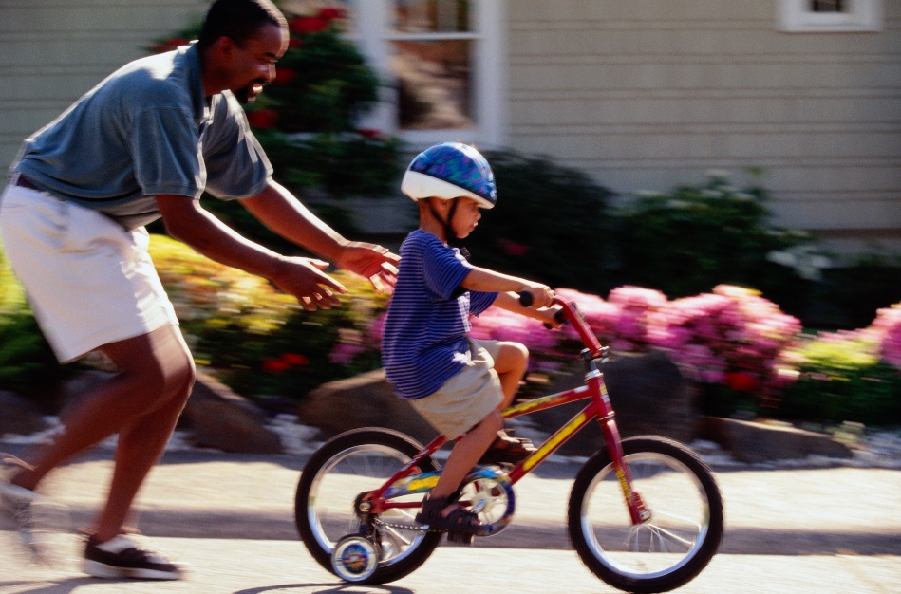
Reminder to our families that have students that ride scooters and bicycles to school.

It is BC Law that all aged cyclists must wear a safety helmet whenever riding on a public road. A parent or guardian must make sure that a child under the age of 16 wears a bike helmet when operating or riding as a passenger on a bike, e-bike or scooter.

3 Books = 1 Gift

The Challenge Continued

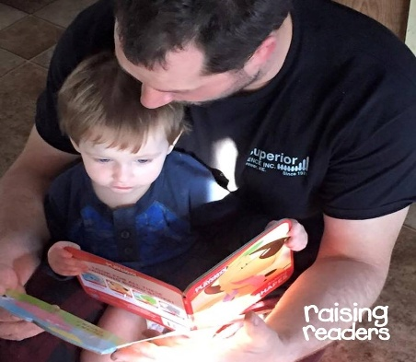
Every week 1000X5 Children’s Book Recycling Project donates 800 of your books
Join the hundreds of families who have taken the three book challenge. As we head into the holiday season, many families appreciate a bit of help with gifts. And what can be a better gift than a bag of 3 books for babies and toddlers? Every month 1000X5 pops 2400 books in 800 gift bags. In the last three weeks, hundreds of books have arrived for the weekly Wednesday sorting by 10 dedicated volunteers.
Drop your books for babies and preschoolers off in the pink bin in the front hallway.


Community Coupon Books Update
We’re Counting the Fundraising Results!
Our team is hard at work tallying all the fundraising that has come in to determine our prize winners. Thanks to your incredible support, we’ve done so well that we are awaiting additional shipments and unsold returns to account for all the coupon books sold!
If you purchased coupon books online after Thursday, please note that prizes for those orders will be awarded on Monday.
Thank you for helping make this fundraiser such a success!

Decorate a Holiday Hat Contest
Pick up a hat template from the library starting next week, and get creative.
Pens, paint, sequins, feathers, pompoms, stickers, pipe cleaners — use your imagination!
Winners will be selected by random draw for participation. Do not forget your name and division


10 Days of Giving:
Winter at McKenzie:
Concert ticket request forms should have arrived home with your students today. Tickets will be distributed on a first come, first served basis. Your child will also be bringing home a poster board next week. The poster board has a tracing of a holiday shape for you and your family to decorate. The decorated shapes will be displayed on the gym walls to add to the winter holiday spirit for our school concerts. Mittens will be sent home December 5th

School Collection for members of our community
On the 1st day of December McKenzie Families donate:  Dry goods!  (ie. Pasta, rice, cereal sugar, pancake mix) | On the 2nd day of December McKenzie Families donate:  Household Paper Products!  (ie. Kleenex, toilet paper, paper towel, napkins) | On the 3rd day of December McKenzie Families donate:  Canned Goods!  (ie. Soup, chili, spaghetti sauce, beans) | On the 4th day of December McKenzie Families donate:  Personal Care!  (ie. Toothpaste, soap, shampoo, feminine hygiene products) | On the 5th day of December McKenzie Families donate: Anything Goes!  
On the 8th day of December McKenzie Families donate:  Treat Day!  (ie. Cookies, popcorn, licorice, chips, chocolate) | On the 9th day of December McKenzie Families donate:  Boxed Goods!  (ie. Crackers, stuffing, coffee, tea) | On the 10th day of December McKenzie Families donate:  Pocket Snacks!  (ie. Granola Bars, wagon wheels, fruit cups) | On the 11th day of December McKenzie Families donate:  Condiments & Spices!  (ie. Ketchup, mustard, syrup, pickles, salt, pepper) | On the 12th^{th} day of December McKenzie Families donate:  Anything Goes!  
Please join us in filling classroom boxes with hamper items for some of our McKenzie families who would appreciate a little help at this time of year. We will be collecting items from Monday, December 1st through until Friday, December 12th.

Please ensure all items donated are:
- Unopened
- Commercially packaged (sorry, no home canned items).
- NOT expired – please check the expiry date before sending the items to the school
PAC NEWS:
Parent & Family Resources:
Erase Family Sessions
These sessions were designed to support families and caregivers in navigating the digital world.
Two sessions are available:
- Establishing Safe, Caring & Respectful Digital Communities - Jan 21, March 11, May 13, all from 6:30 to 7:30
- Establishing Family Practices for Safeguarding Against Cyberbullying and Sextortion - Dec 10, Feb 18, April 8, June 10, all from 6:30 to 7:30
Click to register: Erase Family Sessions

MCKENZIE IS FUNDRAISING

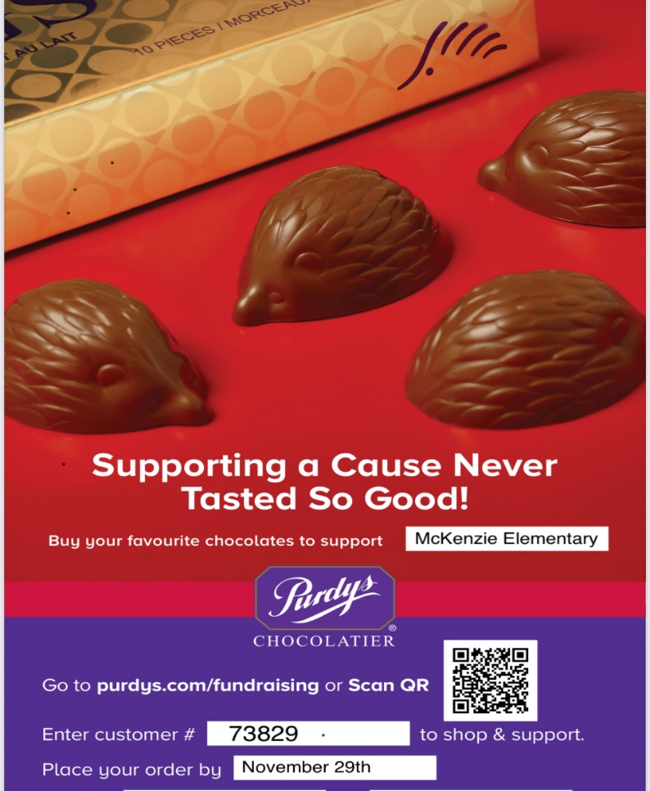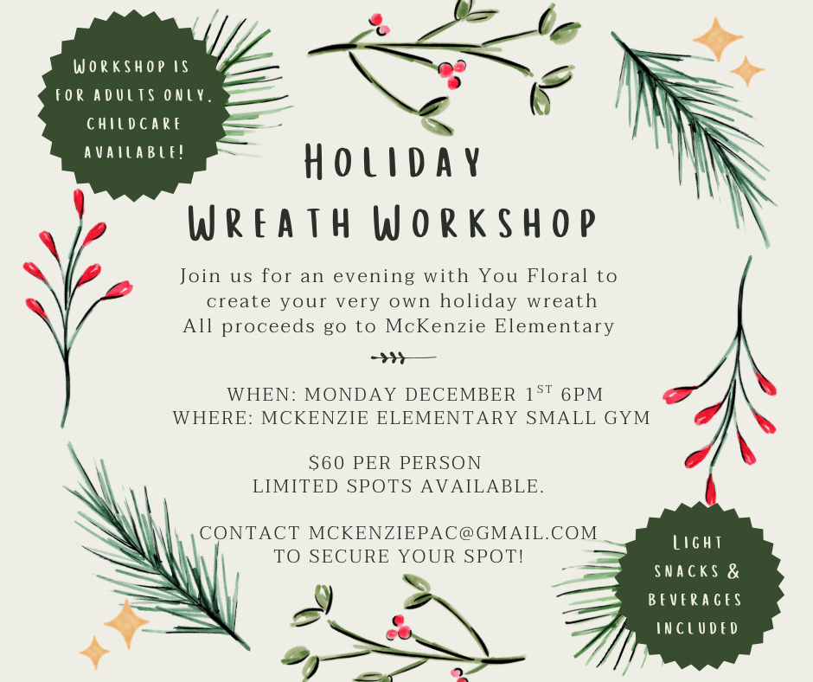
LAST CHANCE TO JOIN

Night of Lights Fundraiser Update:
Thank you to all the families who purchased their Night of Light tickets through the school. It was a wonderful evening, filled with the joy of seeing our community come together and enjoy the event.
Together we fundraised $600.00 towards break room equipment, and our Art Starts fund.

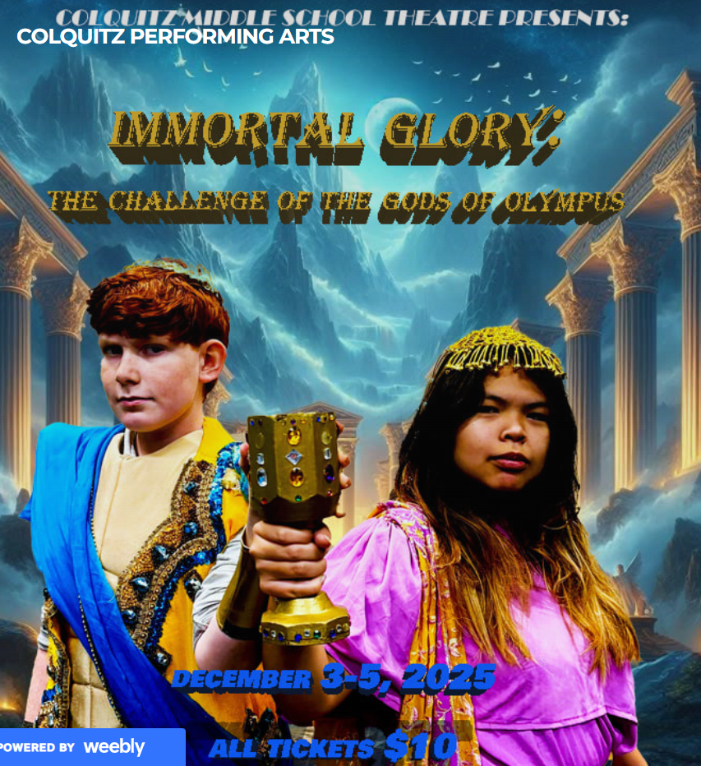

Colquitz Fine Arts Program presents their fall production,
Immortal Glory: The Challenge of the Gods of Olympus.
Tickets can be purchased here: Colquitz Fine Arts

LOCAL EVENTS
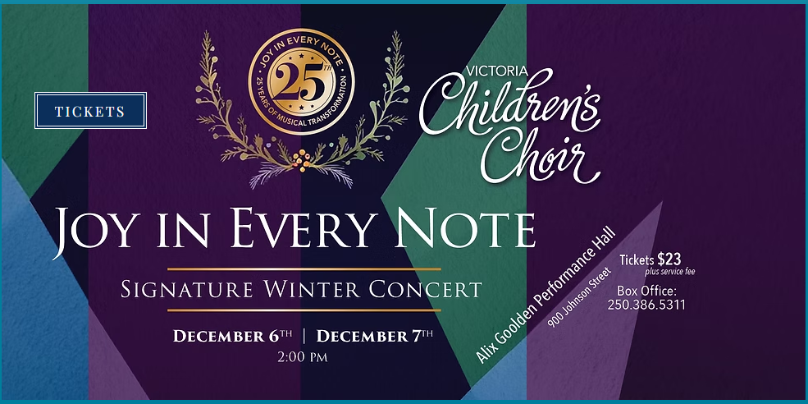

Victoria Children’s Choir present their signature Winter Concert.
Tickets can be purchase here: Victoria Children's Choir

