



**Friday, September 27, 2024**

**McKenzie Elementary School wishes to recognize and acknowledge the Esquimalt and Songhees Nations, on whose traditional territories, we live, we learn, we play, and we do our work.**

### Principal’s Message:

Here we are a month of the 2024/25 school year completed already!

This week was full of many Orange Shirt Day activities and our assembly yesterday. Our student hosts and new stage crew did an EXCELLENT job, and we are so grateful to the family members that were able to join us for the assembly.  Over the weekend there are a variety of activities across the district honouring our National Day of Truth and Reconciliation; including the South Island Powwow; please see the image below for details.

We hope everyone has a wonderful long weekend and we will see you back at school on Tuesday October 1st!

*Carmen*

**Mark your calendar:**

|  |  |  |  |  |
| --- | --- | --- | --- | --- |
| **Monday** | **Tuesday** | **Wednesday** | **Thursday** | **Friday** |
| **Sept 30**  **Statutory Holiday** | **Oct 1**  Cross Country 3:45pm at Lambrick Park High School | **Oct 2** | **A yellow smiley face with black eyes and a smile  Description automatically generatedOct 3**  Photo Day | **Oct 4** |

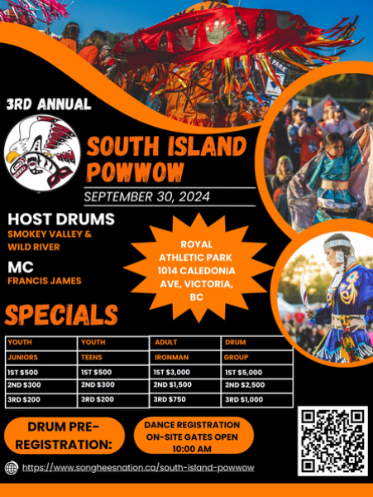

**UPCOMING DATES TO NOTE:**

Oct. 7 – Cross Country at Lambrick Park @ 3:45pm

Oct. 9 – PAC Meeting @ 6.30pm (in-person)

Oct. 14 – Statutory Holiday

Oct. 15 – Cross Country at Lansdowne Field

Oct.16 – Parent Teacher Interviews (**early dismissal - 11:50am**)

Oct. 17 – Parent Teacher Interviews (regular dismissal)

Oct. 17 – Great Canadian Shake Out Drill

Oct. 21 – Cross Country at Beckwith Park @ 3:45pm

**ATTENDANCE:**

Please let us know if your child is going to be absent.

Email: [**attendance27@sd61.bc.ca**](mailto:attendance27@sd61.bc.ca)

Phone: 250-479 1691.

Visit <https://songheesnation.ca/south-island-powwow> for more information.

**PARENT TEACHER INTERVIEWS OCTOBER 16 & 17:**

We are looking forward to meeting with parents and guardians on October 16th and 17th for Parent Teacher interviews. Interviews will be scheduled using School Appointments.com and will go live for booking between Monday, October 7th @ 7am and October 14th @ 7pm. **The link with instructions will be shared in the October 4th newsletter.**

Tuesday Oct. 16th – students will be **dismissed EARLY at the lunch bell (11:50am).** Interview times will be between 12:30pm – 5:30pm

Thursday Oct. 17th – students will be **dismissed at the regular time (2:37pm).** Interview times will be between 3:00pm - 5:30pm

**THE CARD PROJECT is back this fall!**

Our students are participating in this exciting art-based fundraiser.

For purchase: beautiful products made with your child's art! Greeting cards, mugs, canvas tote bags,

tea towels, mouse pads, notebooks, sketchbooks, canvas prints, and more.

Orders open online on Friday, October 18 at [www.TheCardProject.ca](http://www.TheCardProject.ca)

Our school access code is **MK70**

Orders received by October 27 will be delivered in the week of November 18-22.

The final order deadline is November 11, for delivery by December 13.

**Friends Achieving Skills Together Swim Program**

Does your child love to swim? McKenzie School will be putting together a swim team and will be coached by a Pacific Coast Swimming ‘F.A.S.T.’ program coach!

Participants must be able to swim 25 meters unassisted. The program will start Oct 21st and will run Mondays 3:15-4:00pm with occasional Sunday meets. **Parents will be responsible for getting their children to/from the pool and prepped for lessons.** In addition, we will need one parent representative to assist during swim meets. If interested, please email Sam Blair at [sblair@sd61.bc.ca](mailto:sblair@sd61.bc.ca)

Keep your eyes open for the McKenzie Swim Team registration **coming soon via email**!



**FALL CROSS COUNTRY:**

Fall Cross Country is now underway.  Practices are on Wednesdays and Fridays at lunch.  The first meet is this coming Tuesday, October 1st starting at 3:45 p.m.

**There are several cross country runners who have not returned their cross-country forms.  In order for runners to participate at the meet on Tuesday, they MUST have their completed forms returned prior.**

Questions?? Email one of the coaches: Kristy Gregson ([kgregson@sd61.bc.ca](mailto:kgregson@sd61.bc.ca)) and Natalie Mcilmoyle ([nmcilmoyle@sd61.bc.ca](mailto:nmcilmoyle@sd61.bc.ca))

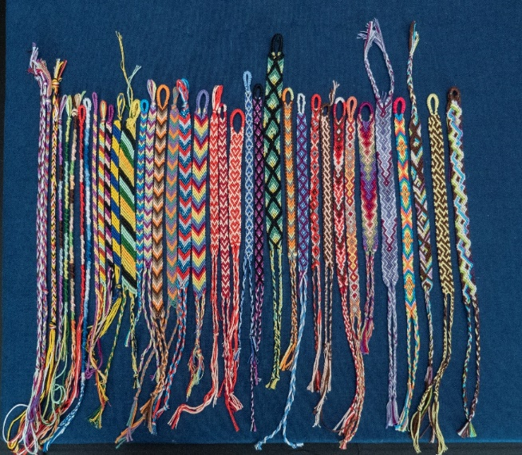

We are still collecting Toonies for Terry and will continue to do so until next Friday, October 4th.

**Calling all Swifties!**

Are you a fan of Taylor Swift? Do you enjoy making friendship bracelets, colouring, dancing, and listening to music? Join our Taylor Swift Club on Mondays at lunch recess in Mrs. McGregor's Room! For Grades 3-5!

Just a reminder that we have a great selection of snacks and lunch add-ons provided each day outside the office.

All students are welcome to help themselves!