Friday, April 5, 2024
McKenzie Elementary School wishes to recognize and acknowledge the Esquimalt and Songhees Nations, on whose traditional territories, we live, we learn, we play and we do our work.

Principal’s Message:
Welcome Back Everyone!

We hope that everyone had a great break. We had a couple of staffing changes over the holiday and we would like to welcome Ms. Michelle Shields as our new teacher in Division 6. In addition, Ms. Hannah Vasilakopoulos has become Mrs. McGregor’s job-share partner in Division 11. Please give our new teachers a warm McKenzie welcome if you happen to see them.

As you know, we posted our Term 2 Learning Updates (Report Cards) on Friday March 15th. At this point in time only 40% of our Term 2 Learning Updates have been read by parents. As mentioned previously, these reports can be found on the Parent Connect site; we do not send paper copies home unless requested. If you have not yet read your child’s Term 2 Learning Update (Report Card) please click the link below to access it:

https://parentconnect.sd61.bc.ca/Identity/Account/Login
Have a good weekend.
Ms. Carmen

Mark your calendar:
Monday | Tuesday | Wednesday | Thursday | Friday
APR 8 | APR 9  Div. 5 & 7 Butchart Gardens | APR 10  Div. 3 to Observatory  PAC Meeting  (online @ 6:30pm via Teams) | APR 11  Popsicle Sale after school | APR 12  Hot Lunch  (subway/sushi)  Order deadline is Sunday, April 7th
UPCOMING DATES TO NOTE:
Apr. 12 – Hot Lunch Day (subway/sushi)
Apr. 15 – Assembly @ 9 a.m.
Apr. 17 – Div. 10 to Swan Lake
Apr. 18 – Visiting Band Performance @ 10:40 a.m.
Apr. 26 – Kindergarten / Grade 1 immunizations
May 1 – PAC Meeting (in-person)
May 6 – Divs 11 & 12 to Butterfly Gardens
When your child is going to be absent from school please let us know by email attendance27@sd61.bc.ca or phone 250-479-1691.

GRADE 5 FUNDRAISER TO SUPPORT CAMP THUNDERBIRD TRIP
POPSICLE SALES

Popsicles are $2 each!
For sale by the C doors, after school on:
Thursday, April 11, 18, 25 and May 2

The Victoria Symphony has made a video to promote their education concerts. Our Grade 4 students attended the concert in February as part of our listening unit in music class. Here is the link:

This video will also be aired on CHEK NEWS this Saturday evening (Apr. 6) as part of a regular broadcast of a Victoria Symphony concert called “Bach and Vivaldi”. The broadcast starts at 8pm, and the video will be about 40 mins into the show.
https://youtu.be/_-7Itz_YxYI
Happy viewing!
MCKENZIE STAMP CLUB

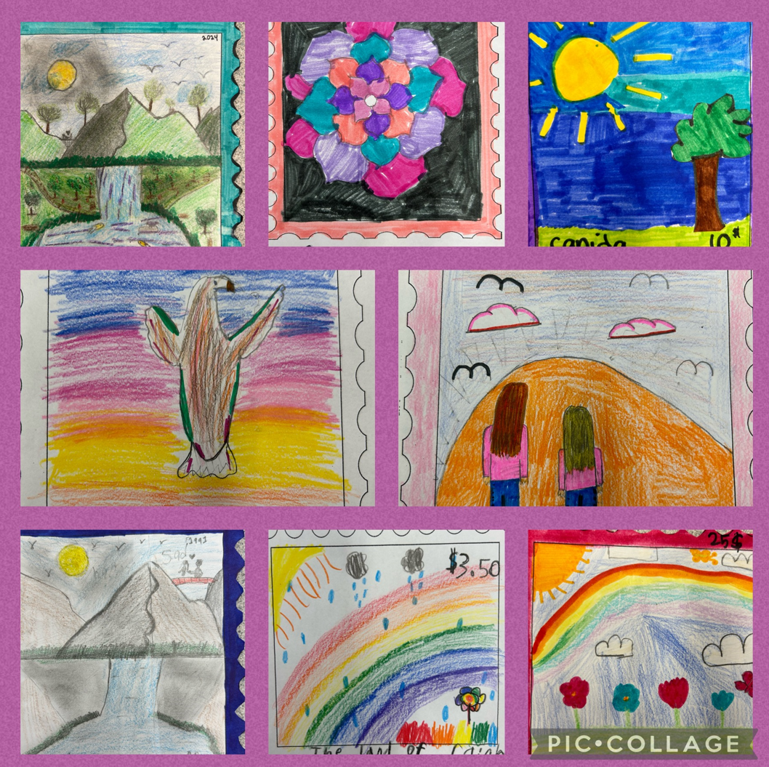

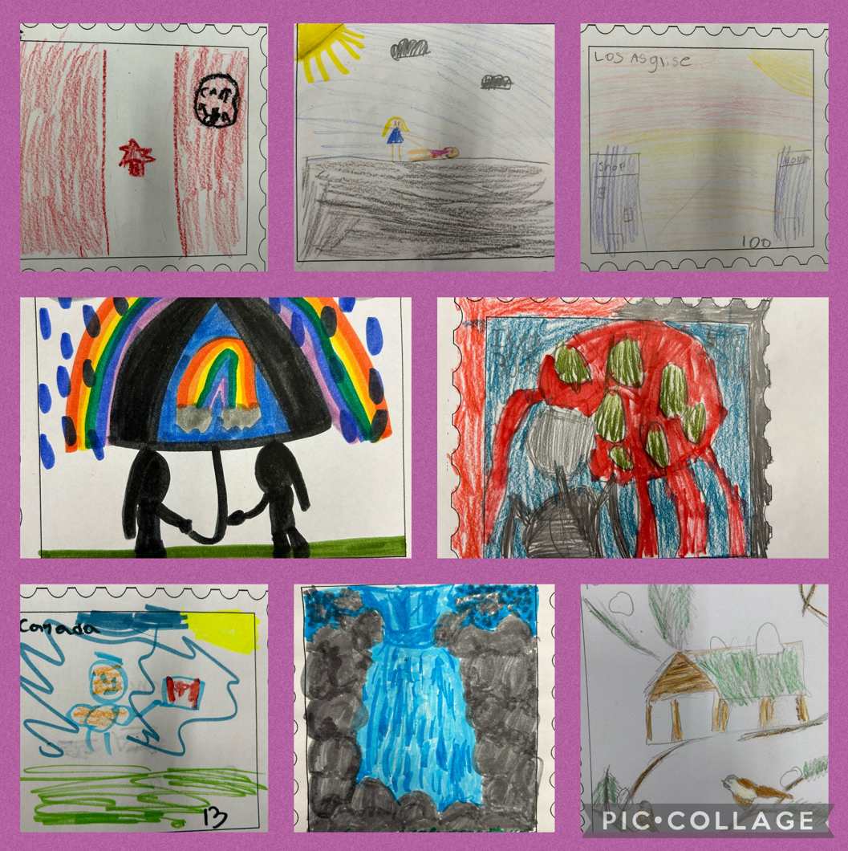

Our McKenzie stamp club has a group of 20-30 students every Wednesday that meets to learn about collecting postage stamps. Students are learning to sort, trade, and soak stamps to add to their collections.

Prior to spring break, we had a “Design your own Stamp” contest. Students were asked to create their own stamps with a picture, country name, and value.
The winning entries were:
Intermediate: Zadie and Melissa
Primary: Nidhi and Emma-lynn

New members are always welcome to join.
We meet on Wednesdays at lunch recess.

APRIL IS AUTISM ACCEPTANCE MONTH & SIKH HERITAGE MONTH:
7 – World Health Day
9-10 - Eid al-Fitr
13 – Vaisakhi
22-30 – Passover
22 – Earth Day
24 – Administrative Professionals’ Day
28 – Day of Mourning for Lost Workers

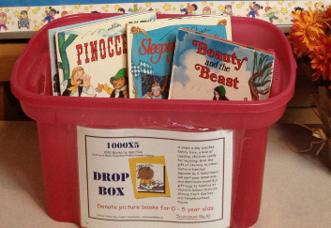
1000x5

Check out the two minute Victoria Foundation video celebrating 1000X5 and our contributions to early literacy. Thanks to all of you for making this project happen.

https://drive.google.com/file/d/1wcoGk5sM6TE8fbOnxmMEKimv0WvupTvN/view?usp=sharing

Take your extra baby and preschooler books to the pink bin in the front hallways and help change a child’s future. 328,000 books and counting!!

PAC NEWS:

PAC MEETING IS ONLINE ON WEDNESDAY, APRIL 10 @ 6:30pm
Join the meeting now
Meeting ID: 279 866 514 996
Passcode: FzFYkD

SPECIAL FOOD DAY!
Friday, April 12th is Special Food Day at McKenzie!
Subway and Sushi
Order deadline is Sunday, April 7th
To order visit https://mckenzie.hotlunches.net
Access Code is MEHL
Questions? Please email mckenziehotlunch@gmail.com

