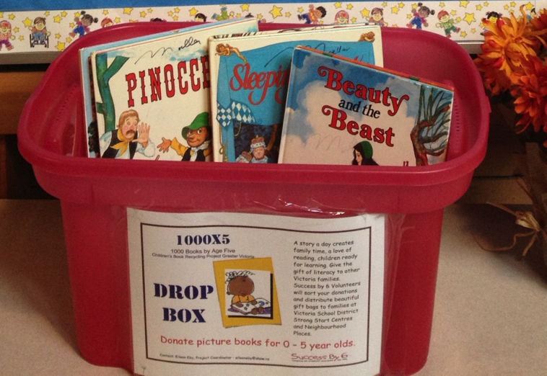

Have you found the pink bin in the front entrance at McKenzie?
The 2016-2017 year has begun and along side the children entering the building are the 15 retired teachers and principals who meet every Wednesday to sort your donations of books for babies and preschoolers. Every month we send 800-1000 books into homes with few resources. 110,000 books in five years! Please give the opportunity for early literacy to more families in our communities.

